

Complete Test Protocols & SOP

Data | 23.04.2026
Version | 03
Prepared by
Battery Test Engineer | Zawar Qureshi
Agreed by
Head of Cell Design/Development | Morten Vaalma

Contents
0) Cell, Blocks, Limits, and Global Assumptions 4
1) Conversion: Current Density ↔ Current (173.24 cm²) 8
2) Recommended Overall Order of Testing for Cells 8
3) Standard Program 9
3A) Objective 9
3B) Preparation 9
3C) Test Sequence 9
3D) Calculations & Definitions 10
3E) Reporting (every cycle) 11
4) EDLC ↔ redox transition mapping (CV multi‑rate). 13
4A) Objective 13
4B) Preparation 13
4C) Test Sequence 13
4D) Calculations & Definitions 13
4E) Reporting 14
5) Cyclability 15
5A) Objective 15
5B) Preparation 15
5C) Test Sequence 15
5D) Calculation & Definitions 15
5E) Reporting 15
6) Calendar Aging 17
6A) Objective 17
6B) Preparation 17
6C) Test Sequence 17
6D) Calculation & Definitions 17
6E) Reporting 17
7) Leakage Current 18
7A) Objective 18
7B) Preparation 18
7C) Test Sequence 18
7D) Calculation & Definitions 18
7E) Reporting 18

0) Cell, Blocks, Limits, and Global Assumptions
- Cell geometry: 160 × 140 mm; slurry‑coated active area: 142 × 122 mm = 173.24 cm² (for current‑density calculations). Stacked positive/negative electrodes with separator, compressed in a metallic fixture. Terminals are copper current-collector tabs, each tab 20 mm × 50 mm (50 microns) (Figure 1).
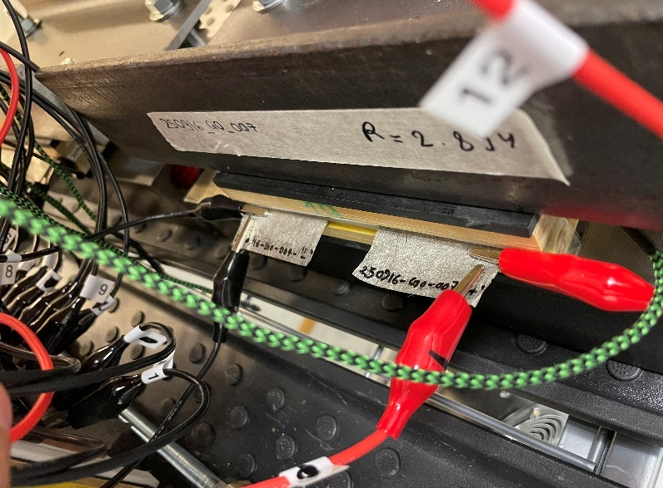
Figure 1: Assembled Single-Cell.
- Block geometry: Multiple cells in series under the same style of steel compression fixture, Figure 2. No copper tabs: instead, aluminum radiators at the top and bottom serve as the positive and negative terminals.
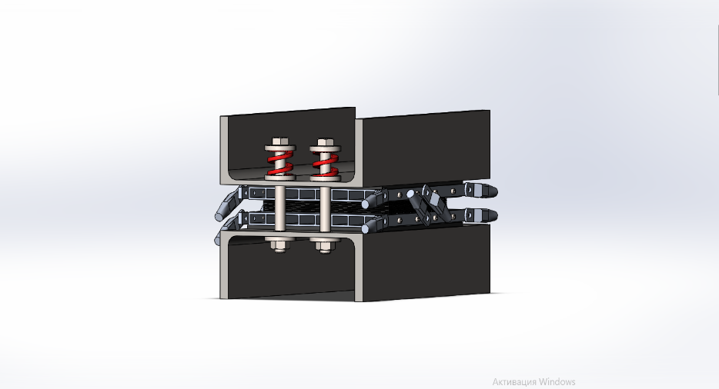
Figure 2: Block Fixture.
- Per cell nominal operating voltage window: 0.85 → 1.70 V (non-zinc)
- Per cell nominal operating voltage window: 1.70 → 1.75 V (zinc)
- Equipment:
  - 12 multi-Channel Cycler (Figure 3): Voltage operating range of 0.1 V to 20 V and current operating range of 10 mA to 10 A. Multiple channels can be connected in parallel to deliver higher currents. No GANG mode for parallel operation. 4-point connection (force/sense), each terminated with kelvin clamps, 100 Hz sampling max.
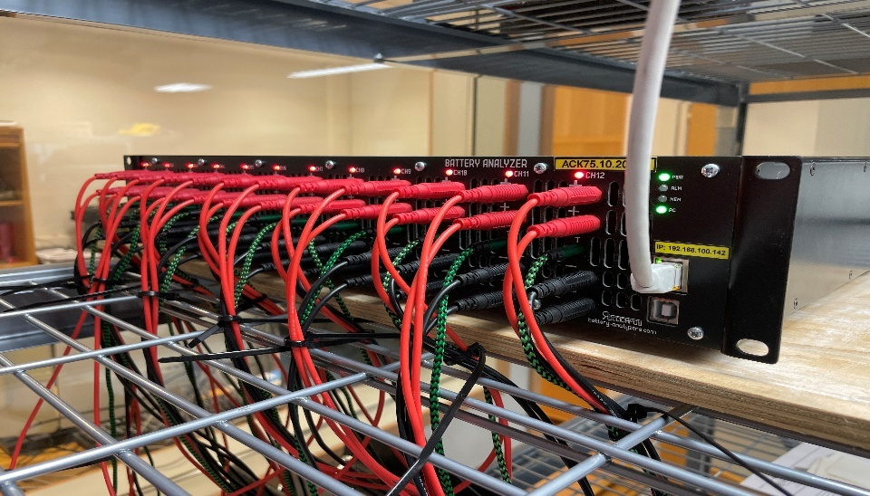
Figure 3: Multi-Channel Cycler ACK75.10.20.12.
  - Single Channel Cycler (Figure 4): Voltage operating range of 1 V to 56 V and current operating range of 2 A to 75 A. 4-wire (force/sense), force wires terminated with lugs and sense wires terminated alligator clips, 10 Hz sampling max.
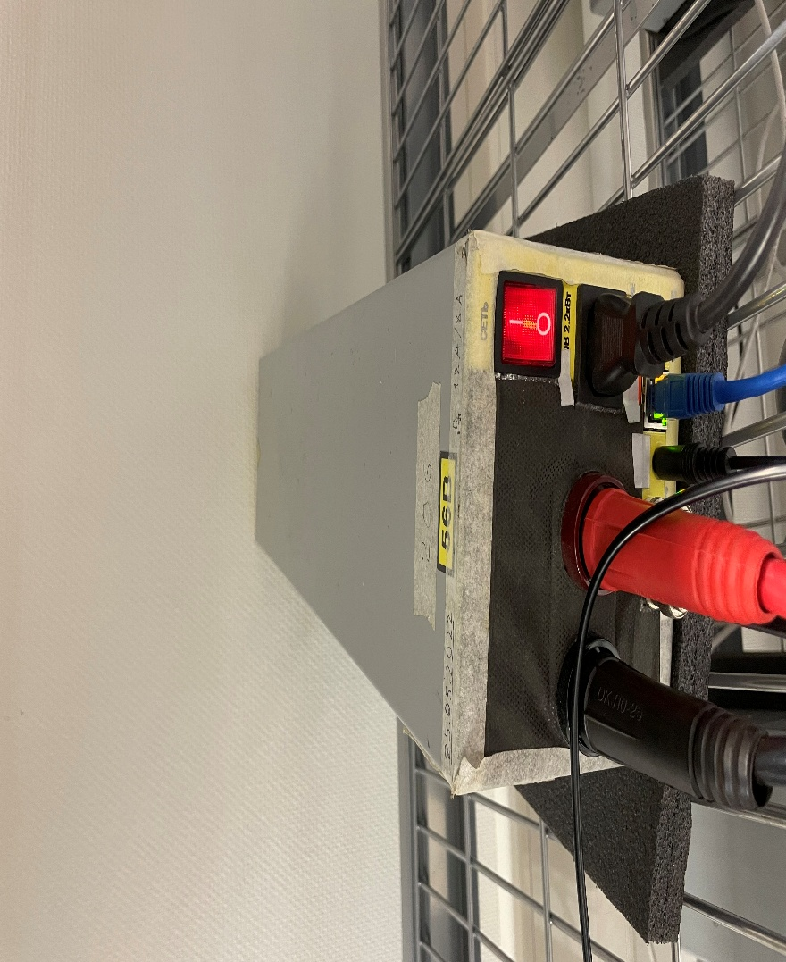
Figure 4: Single Channel Cycler ACK75.48.1750.1.
- Fixtures & leads: 4‑wire (force/sense) terminating with kelvin connection, per channel. F+ (Force+), F− (Force−), S+ (Sense+), S− (Sense−).
  - For Testing Cells (two 20x50 mm Cu Tabs) – use kelvin clamps.
  - For testing Blocks with Radiators – see Figure 5:
- S+: + radiator, BOTTOM Side Lateral face, 10 ± 2 mm from the stack interface, alligator clipped next to terminal post.
- F+: + radiator, BOTTOM Side Lateral face, lug attached to terminal post.
- S−: − radiator, TOP Side Lateral face, 10 ± 2 mm from the stack interface, alligator clipped next to terminal post.
- F−: − radiator, TOP Side Lateral face, lug attached to terminal post. Mirror symmetry.
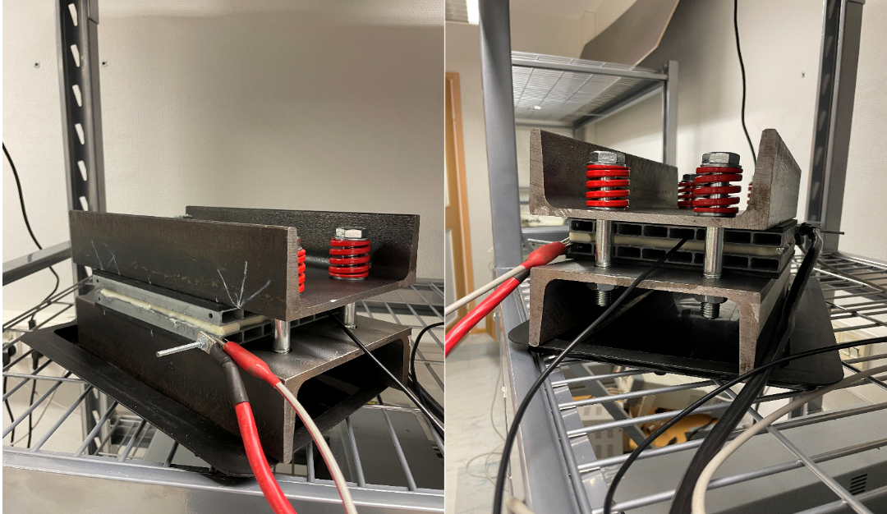
Figure 5: Connections for Blocks.
- Polarity convention: Charge current I > 0, discharge I < 0. Voltage reported as positive full‑cell.
- Absolute Voltage hard limit: 1.80 V per cell hard stop.
- Absolute Temperature hard limit: 50 °C. Keep airflow consistent; avoid fan directly on cell unless you test thermal effects.

1) Conversion: Current Density ↔ Current (173.24 cm²)
Formula: $I\left[A\right]= j\left[mA.cm^{-2}\right] 0.17324$
j (mA·cm⁻²) | 10 | 20 | 50
I (A) | 1.732 | 3.465 | 8.662
*Document any other j → I conversion if used

2) Recommended Overall Testing for Cells
For Production Team:
- Standard Program.
Additional Tests for Research Team:
- EDLC ↔ redox transition mapping (CV multi‑rate).
- Cyclability.
- Calendar Aging.
- Leakage Current Test.
- Self-Discharge Test.

3) Standard Program

3A) Objective
The objective of the test is to inspect chemistry and determine the Capacitance, Energy, ESR10ms and ESR1s for the cells.

3B) Preparation
- Visually inspect for swelling, leaks, or salt crystallization.
- Cells will be tested on multi-channel cyclers ACK. 75.10.20.12 only.
- Establish kelvin connections.
- Sample at 100 Hz.
- Use Temperature and Voltage hard limits as discussed in Section 0.

3C) Test Sequence
Program Name: “Standard Test” (runtime approx. 1h)
- Rest 1s.
- 3 Cycles of Cyclic Voltammetry from 0.5V to 1.72V at 10 mV/s.
- Discharge CC @ 20 mA·cm⁻² (3.5 A) to 0.85 V.
- CV hold for 30 sec at 0.85 V.
- Charge CC @ 20 mA·cm⁻² (3.5 A) to 1.70 V (V₁).
- Rest 1s.
- Discharge CC @ 20 mA·cm⁻² to 0.85 V (V₂).
- Rest 1 s.
- Cycle to Step 4, 20 times.
- Discharge CC @ 20 mA·cm⁻² to 0.1 V.

3D) Calculations & Definitions
Capacitance will be determined from the linear discharge slope under load, so ESR does not corrupt it. ESR will be determined from voltage rebound after current interruption for 10ms and 1s. The parameters for the calculations and the corresponding equations are provided below:
A) Capacitance: - Compute from discharge cycle
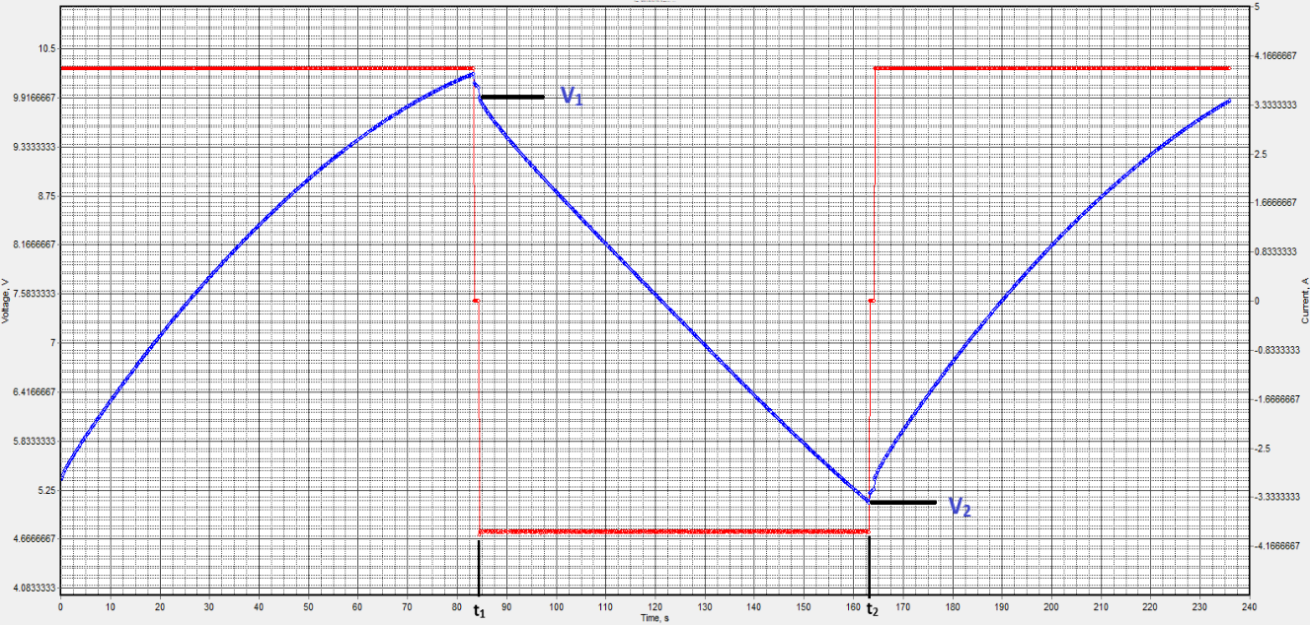
Figure I: Capacitance Calculation.
- Report:
$C= \left|I\right|·\frac{t_{2}- t_{1}}{V_{1}- V_{2}}$
- with $\left|I\right|=4.0 A,$ and V₂ = 5.10 V.
- Reporting rule: Capacitance values are the average of the last 5 cycles.
B) ESR: Compute from discharge cycle
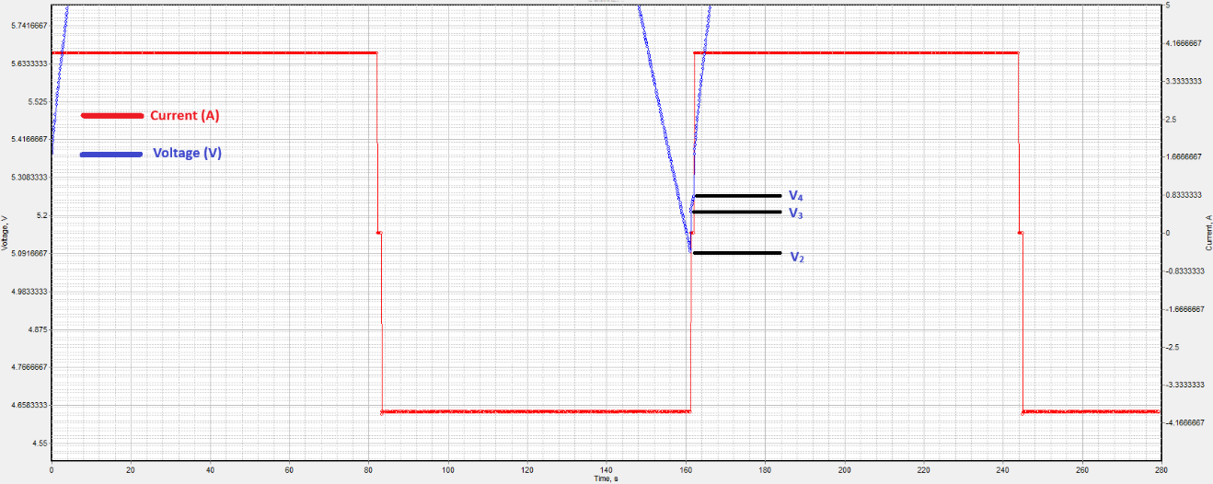
Figure 2: ESR Calculation
- $V_{2}$ = last voltage sample under discharge current
- $V_{3}$= voltage 10 ms after current interruption
- $V_{4}$ = voltage 1.0 s after rest
- I_{dchg}= current during discharge
- Report:
$$ESR_{10ms}=\frac{V_{3}- V_{2}}{\left|I_{dchg}\right|}$$
$$ESR_{1s}=\frac{V_{4}- V_{2}}{\left|I_{dchg}\right|}$$
- Reporting rule: ESR values are the average of the last 5 cycles.

3E) Reporting (every cycle)
No. | KPI | Unit | Formula
1 | Cell Rated Capacitance | F | As per Figure 1 or cycler value
2 | Cell ESR_{10ms} | mΩ | As per Figure 2
3 | Cell ESR_{1s} | mΩ | As per Figure 2
4 | Cell Stored Energy | Wh | $\frac{\frac{1}{2}CV_{R}^{2}}{3600}$ or charge value from cycler
5 | Cell Useable Energy | Wh | $\frac{\frac{1}{2}C[{\left(V_{R}-\left(I_{dchg}×((2×ESR_{10ms})+ESR_{1s}\right)\right)}^{2}-{\left(V_{min}\right)}^{2}]}{3600}$ or discharge value from cycler
6 | Cell Max Peak Current, 1s | A | $$\frac{\frac{1}{2}{CV}_{R} }{(C ×ESR_{1s})+1s}$$
7 | Cell Nominal Power | kW | $$\frac{\frac{V_{R}^{2} }{4 × ESR_{1s}}}{1000}$$
12 | Cell Stored Specific Energy | Wh/kg | $$\frac{Cell Stored Energy (Wh)}{cell mass}$$
13 | Cell Stored Energy Density | Wh/L | $$\frac{Cell Stored Energy (Wh)}{cell volume}$$
15 | Cell Useable Specific Energy | Wh/kg | $$\frac{Cell Useable Energy (Wh)}{cell mass}$$
16 | Cell Useable Energy Density | Wh/L | $$\frac{Cell Useable Energy (Wh)}{cell volume}$$
21 | Cell Power Density | kW/L | $$\frac{Cell Nominal Power (kW)}{cell volume}$$
22 | Cell Specific Power | kW/kg | $$\frac{Cell Nominal Power (kW)}{cell mass}$$
23 | Cell Capacity | Ah | For charge and discharge cycles from cycler
24 | Coulombic & Energy efficiency | % | From cycler
25 | Temperature | C | From cycler

4) EDLC ↔ redox transition mapping (CV multi‑rate).

4A) Objective
To define and compare regime characteristics of cells across various designs/samples/batches.

4B) Preparation
- Visually inspect for swelling, leaks, or salt crystallization.
- This test will be performed on the Electrochemical instruments P40X Potentiostat
- Establish kelvin connections.
- Sample at 100 Hz.
- Use Temperature and Voltage hard limits as discussed in Section 0.

4C) Test Sequence
Program name: “CV Mapping”
- Start at 0.50 V.
- Scan rates ($υ$ = 1, 2, 3, 4, 5, 6, 7, 8, 9, 10 $\frac{mV}{s}$).
- Sweep 0.50 → 1.72 V → 0.50 V: absolute guard 1.75 V.
- Log i–V at 100 Hz.

4D) Calculations & Definitions
In EDLC, $i\left(V\right)=C\left(V\right) ν$. Thus $Cν(V)=\frac{\left|i(V)\right|}{ν}$overlays for different scan rates. Redox introduces non‑linear, non‑invariant features.

Analysis steps:
  - Compute $( C_{V}(V)=\frac{\left|i\left(V\right)\right|}{ν})$ for each $ν$. Smooth with a light SG filter (e.g., window 11–21 samples, poly 2) if noisy; never distort peaks.
  - EDLC criterion: overlays within ±5–10% across $ν$ over a contiguous V‑span.
  - Onset V _{redox, on} first sustained V where overlays diverge (>10% for ≥25 mV span) and/or peaks appear. Optionally compute b‑value: slope of $log \left|i(V)\right|$ vs $log ν$. b ≈ 1 = capacitive; b < 1 trending to ~0.5 = diffusion-limited faradaic. Define onset where b first drops below 0.9 (or your chosen threshold) for >25 mV span. Threshold: b < 0.90 sustained over ≥25 mV indicates faradaic contribution. Define V_{EDLC, max} as the upper V on charge where EDLC criterion still holds.
  - Report both charge and discharge onsets; use charge for operational ceiling selection (more conservative regarding OER risk).

4E) Reporting
- i–V plots
- C_{v} (V) overlays
- b(V) (optional)
- V_{EDLC, max}
- V_{redox, onset}

5) Cyclability

5A) Objective
Characterizing degradation from active charge-discharge cycles.

5B) Preparation
- Visually inspect for swelling, leaks, or salt crystallization.
- Cells will be tested on multi-channel cyclers ACK. 75.10.20.12 only.
- Establish kelvin connections.
- Sample at 100 Hz.
- Use Temperature and Voltage hard limits as discussed in Section 0.

5C) Test Sequence
Program name: “Cyclability”
- For N cycles (e.g., ≥ 10000):
1. CC charge to 1.70 V.
2. CC discharge to 0.85 V.
- Every 1000 cycle: log metrics

5D) Calculation & Definitions
For cyclability, every 1000 cycles is a check point. After every checkpoint the metrics within section 5E must be reported. Due to asymmetric chemistry, a cell may look acceptable on one metric while degrading badly on another.

5E) Reporting
- ESR 10ms and 1s
- Discharge Capacitance
- Discharge energy
- Specific Discharge energy
- Temperature

6) Calendar Aging

6A) Objective
Characterizing time-dependent degradation due to long term storage based on shelf-life.

6B) Preparation
- Visually inspect for swelling, leaks, or salt crystallization.
- Cells will be tested on multi-channel cyclers ACK. 75.10.20.12 only.
- Establish kelvin connections.
- Sample at 100 Hz.
- Use Temperature and Voltage hard limits as discussed in Section 0.

6C) Test Sequence
Program name: “Standard Test”

6D) Calculation & Definitions
Every month, remove cells from storage and connect them to the cycler. Execute the standard test and report metrics.

6E) Reporting
- ESR 10ms and 1s
- Discharge Capacitance
- Discharge energy
- Specific Discharge energy
- Temperature

7) Leakage Current

7A) Objective
Characterizing leakage current for cell/sample/batch.

7B) Preparation
- Visually inspect for swelling, leaks, or salt crystallization.
- Cells will be tested on multi-channel cyclers ACK. 75.10, and blocks on ACK 75.48.
- Establish kelvin connections.
- Sample according to equipment functionality.
- Use Temperature and Voltage hard limits as discussed in Section 0.

7C) Test Sequence
Program name: “Standard Test”

7D) Calculation & Definitions
Every month, remove cells from storage and connect them to the cycler. Execute the standard test and report metrics.

7E) Reporting
- ESR 10ms and 1s
- Discharge Capacitance
- Discharge energy
- Specific Discharge energy
- Temperature

